St Augustine of Canterbury Catholic Primary School
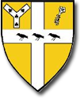
Whole School Curriculum Map for PE

